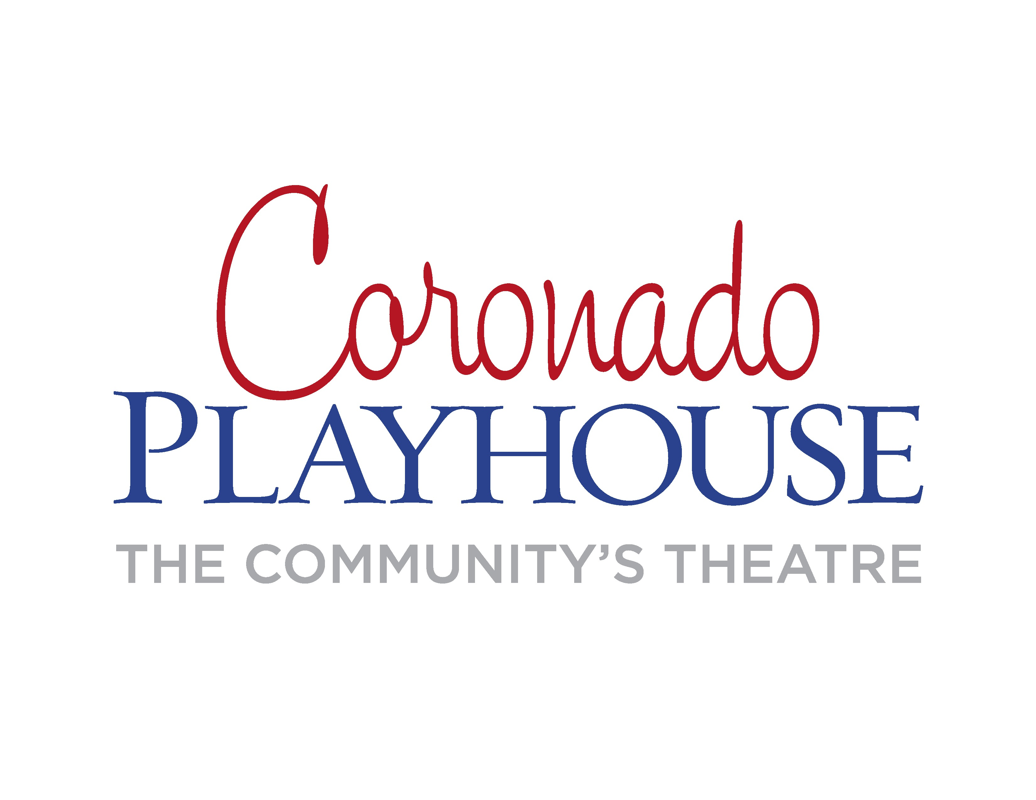
FOR IMMEDIATE RELEASE:
April 20, 2016
CONTACT:
Coronado Playhouse Box Office:
(619) 435-4856
boxoffice@coronadoplayhouse.com
Mary L. Smith, Director:
(619) 757-7186
marylousmith2001@yahoo.com

Coronado Playhouse’s 70th Anniversary
Season Continues with Sordid Lives
Benefitting Stepping Stone of San Diego
May 27-June 26, 2016

Coronado Playhouse is the longest running community theatre in San Diego County and Coronado’s oldest arts organization. The 2016 season marks 70 years of entertainment, service and outreach to Coronado and Southern California audiences.

The Anniversary season continues with Sordid Lives, a hilarious black comedy about white trash. Sordid Lives begins right after Peggy, an upstanding moral woman, hits her head on the sink and dies after tripping over her married lover's wooden legs in a seedy motel room. Chaos erupts in Winters, Texas, as the dysfunctional family deals with their own demons while preparing for what could be an embarrassing funeral. The hilarity is nonstop as the unlikely characters come to life in this award-winning story that is, ultimately, one of acceptance and family values.

During the six-week run of performances May 27-June 26, Coronado Playhouse, the Community's Theatre, is raising money and awareness for Stepping Stone of San Diego, Inc. Stepping Stone has helped save lives for the past 40 years as one of the nation's only alcohol and drug treatment facility specializing in the Gay, Lesbian, Bisexual and Transgender community. For more information visit steppingstonesd.org.

Sordid Lives special events include:
Opening Night Dinner and Show Package Friday, May 27 at 6:30p.m. Don’t miss this special buffet dinner and show for only $50 per person. The delicious catered meal will be served from 6:30-7:30pm. Show starts at 8pm.
Backstage Pass Coronado Playhouse members receive a complimentary guided walk backstage 15 minutes prior to each show and see the pre-show activity behind the curtain. Non-members can join the tour for $20 which can be deducted when purchasing an optional membership package.
The comedy Sordid Lives, written by Del Shores, author of Daddy's Dyin' (Who's Got the Will?), was nominated for over 30 awards during its long run in Los Angeles in the late 1990s. The show is directed by Mary L. Smith and produced by Lynn Wolsey. The cast features Susan Bray as Bitsy Mae Harling, Erik Cram as Ty Williamson, Mary Ann Van Sickle as Sissy Hickey, Carolyn Wheat as Noleta Nethercott, Heather Deerfield as Latrelle Williamson, Angie Doren as La Vonda Dupree, Michael Madden as G.W. Nethercott, Larry E. Fox as Wardell Owens, Eric Thompson as Odell Owens/Reverend Barnes, Cambria Rose Ruth as Dr. Eve Bolinger, Jay Keener-Welsch as Earl “Brother Boy” Ingram and Peggy Daly as Juanita.

For more information and to purchase tickets please contact the box office at
619-435-4856 or go to our website, www.coronadoplayhouse.com.
DATES: May 27-June 26, 2016
TIMES: Thursdays - Saturdays at 8:00 p.m., Sundays 2:00 p.m.
TICKETS: $20-$27 Active Duty Military, Student and Senior discounts. Excellent group rates are available.

SORDID LIVES is produced by special arrangement with Samuel French, Inc.
Please contact the box office for media interest and needs. Coronado Playhouse is a qualified 501(c) 3 non-profit organization as San Diego County’s longest running community theatre.

