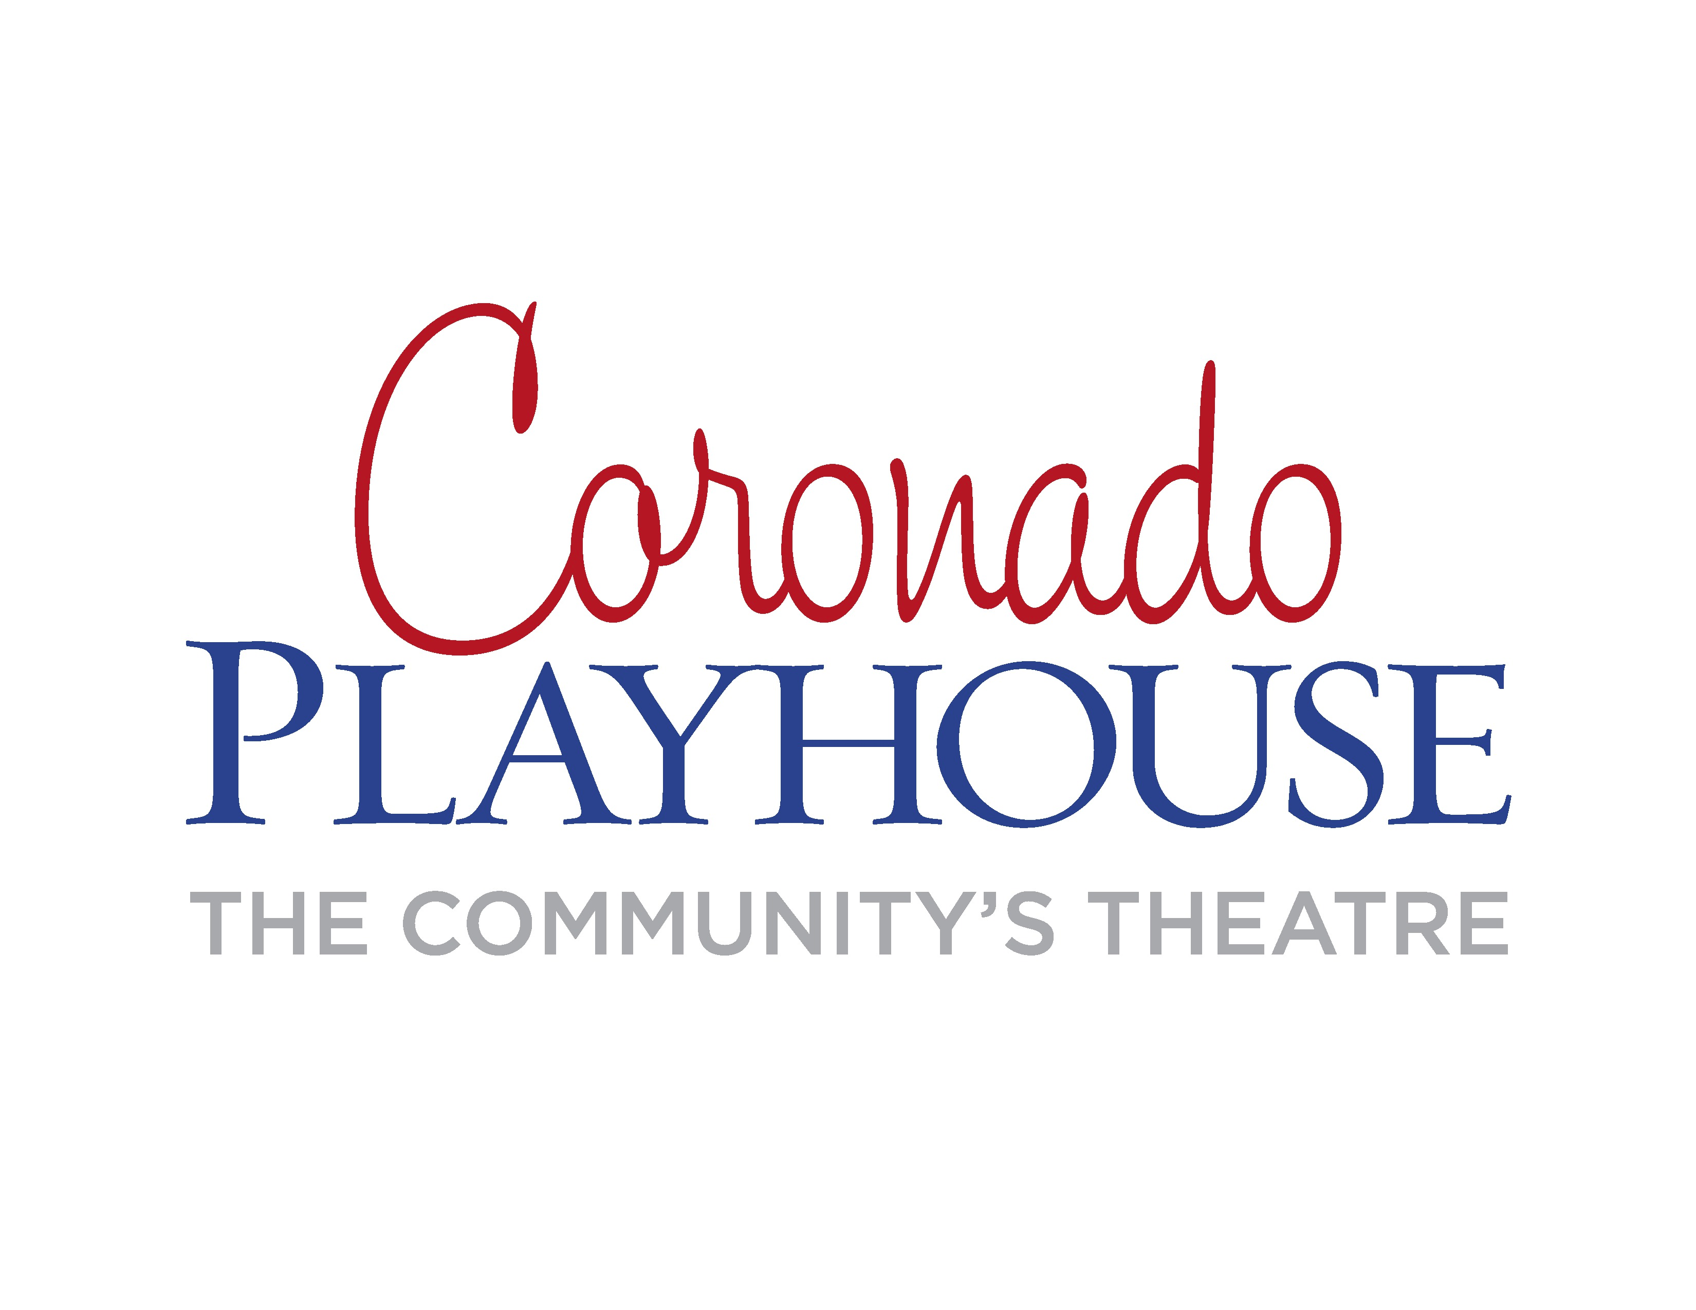
FOR IMMEDIATE RELEASE:
January 6, 2016
CONTACTS:
Barron Henzel, Producer (619) 322-1371
barron@coronadoplayhouse.com
Coronado Playhouse Box Office (619) 435-4856
boxoffice@coronadoplayhouse.com

Coronado Playhouse’s 70th Anniversary
Season Begins with
Sugar, based on the screenplay Some Like it Hot
Benefitting Mama’s Kitchen
January 29-March 6, 2016

Coronado Playhouse is the longest running community theatre in San Diego County and Coronado’s oldest arts organization. The 2016 season marks 70 years of entertainment, service and outreach to Coronado and area audiences.

The season begins with the award-winning musical, Sugar, based on the classic film Some Like it Hot starring Marilyn Monroe, Tony Curtis and Jack Lemmon. These characters lit up the silver screen and the Hotel Del where it was filmed, and were recreated for the Broadway stage in the hit 1972 musical Sugar. In this zany musical adventure, two unemployed musicians witness a Chicago gang rub-out in 1931. Forced to disguise themselves as women, they join an all-female band about to leave town for an engagement in Miami Beach. You will love these memorable characters that made the movie so popular.

During the six-week run of performances January 29-March 6, 2016, Coronado Playhouse, the Community's Theatre, is raising money and awareness for Mama’s Kitchen, San Diego County's food delivery service providing nutrition support to men, women, and children affected by AIDS or cancer who are vulnerable to hunger. For more information, visit http://www.mamaskitchen.org.

Other Sugar special events include:
Opening Night Dinner and Show Package Friday, January 29 at 6:30p.m. Don’t miss this special buffet dinner and show for only $50 per person. The delicious catered meal will be served from 6:30-7:30pm. Show starts at 8pm.
Tequila Tasting Pre-Show Mixer Thursday, February 4 at 6:30p.m. $25 includes the tasting, hors d’oeuvres and admission to the show.
ASL Performance. A sign language interpreter will sign a performance on Sunday, February 7 at 2p.m. for those who are hearing impaired. Please join us for this special performance at no additional charge. Call the box office for more information.
Sugar’s Valentines Day Happy Hour Saturday, February 13 at 6:30p.m. $10 add-on includes delicious hors d'oeuvres, complimentary glass of champagne and sweets. Sweetheart raffle of goodies held during intermission. Show starts at 8p.m.

The Sugar cast features Kristen Fogle (Sugar Kane), Colden Lamb (Jerry/Daphne), David Guthrie (Joe/Josephine), Kimberly Miller (Sweet Sue), Brent Roberts (Bienstock), Meredith Russo (Spats Palazzo /Dance Captain), Steve Jensen (Sir Osgood Fielding), Manny Bejarano (Knuckles Norton), Kristen Goodhart (Rosella), Caralee Loibl (Olga), Stephaine Nesbitt (Dolores), Melanie Williams (Mary Lou), Kelly-Noelle Henry (Ensemble), Ben Sutton (Ensemble), Todd Sutton (Ensemble) and Matt FitzGerald (Ensemble).

The production team includes Rayme Sciaroni (Director and Choreographer), Benjamin Goniea (Musical Director), Katy Skyrud and Barron Henzel (Producers), Marcee Drysdale (Costumer), Francia Cohen (Wig Mistress/Makeup Direction), Xavier Luevano (Lighting Design), Darian Beckstrand (Stage Manager), Alex Heath (Sound Design), Rick Anthony (Sound Design/Tech), Jack Connard (Sound Operator), Ric Michaels (Spot Operator), Pamela Everett (Props and Dressing).

For more information and to purchase tickets please contact the box office at
619-435-4856 or go to our website, www.coronadoplayhouse.com.
DATES: January 29-March 6, 2016
TIMES: Thursdays - Saturdays at 8:00 p.m., Sundays 2:00 p.m.
TICKETS: $20-$27 Active Duty Military, Student and Senior discounts. Excellent group rates are available.

Sugar
Book by Peter Stone
Based on the Screenplay “Some Like It Hot”
by Billy Wilder and I.A.L. Diamond
Based on a Story by Robert Thoeren
Music by Jule Styne
Lyrics by Bob Merrill

SUGAR is presented by arrangement with TAMS WITMARK MUSIC LIBRARY, INC. 560 Lexington Avenue, New York, New York 10022. Please contact Barron Henzel for specific media interest and needs. Coronado Playhouse is a qualified 501(c) 3 non-profit organization as San Diego County’s longest running community theatre.

###

